CLIMATE CHANGE
By Filtzanidi Dimitra, Plaggenti Ioanna, Platsi Kyriaki, Roussou Aliki
Climate change refers to long-term shifts in temperatures and weather patterns. Such shifts can be natural, due to changes in the sun’s activity or large volcanic eruptions. But since the 1800s, human activities have been the main driver of climate change, primarily due to the burning of fossil fuels like coal, oil and gas.
CAUSES
Generating power
Generating electricity and heat by burning fossil fuels causes a large chunk of global emissions. Most electricity is still generated by burning coal, oil, or gas, which produces carbon dioxide and nitrous oxide – powerful greenhouse gases that blanket the Earth and trap the sun’s heat. Globally, a bit more than a quarter of electricity comes from wind, solar and other renewable sources which, as opposed to fossil fuels, emit little to no greenhouse gases or pollutants into the air.
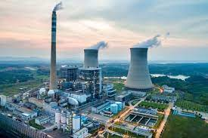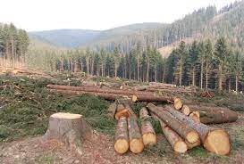
Cutting down forests
Cutting down forests to create farms or pastures, or for other reasons, causes emissions, since trees, when they are cut, release the carbon they have been storing. Each year approximately 12 million hectares of forest are destroyed. Since forests absorb carbon dioxide, destroying them also limits nature’s ability to keep emissions out of the atmosphere. Deforestation, together with agriculture and other land use changes, is responsible for roughly a quarter of global greenhouse gas emissions.
Consuming too much
Your home and use of power, how you move around, what you eat and how much you throw away all contribute to greenhouse gas emissions. So does the consumption of goods such as clothing, electronics, and plastics. A large chunk of global greenhouse gas emissions are linked to private households. Our lifestyles have a profound impact on our planet. The wealthiest bear the greatest responsibility: the richest 1 per cent of the global population combined account for more greenhouse gas emissions than the poorest 50 per cent.
EFFECTS
Hotter temperatures
As greenhouse gas concentrations rise, so does the global surface temperature. The last decade, 2011-2020, is the warmest on record. Since the 1980s, each decade has been warmer than the previous one. Nearly all land areas are seeing more hot days and heat waves. Higher temperatures increase heat-related illnesses and make working outdoors more difficult. Wildfires start more easily and spread more rapidly when conditions are hotter. Temperatures in the Arctic have warmed at least twice as fast as the global average.
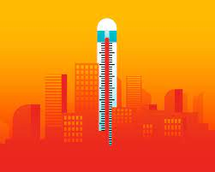
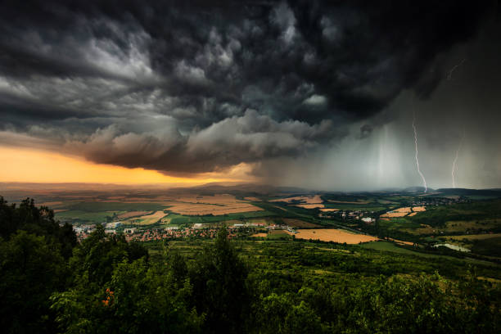
More severe storms
Destructive storms have become more intense and more frequent in many regions. As temperatures rise, more moisture evaporates, which exacerbates extreme rainfall and flooding, causing more destructive storms. The frequency and extent of tropical storms is also affected by the warming ocean. Cyclones, hurricanes, and typhoons feed on warm waters at the ocean surface. Such storms often destroy homes and communities, causing deaths and huge economic losses.

A warming, rising ocean
The ocean soaks up most of the heat from global warming. The rate at which the ocean is warming strongly increased over the past two decades, across all depths of the ocean. As the ocean warms, its volume increases since water expands as it gets warmer. Melting ice sheets also cause sea levels to rise, threatening coastal and island communities. In addition, the ocean absorbs carbon dioxide, keeping it from the atmosphere. But more carbon dioxide makes the ocean more acidic, which endangers marine life and coral reefs.
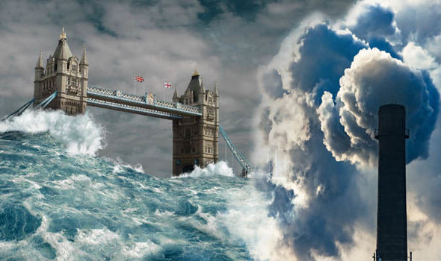
Loss of species
Climate change poses risks to the survival of species on land and in the ocean. These risks increase as temperatures climb. Exacerbated by climate change, the world is losing species at a rate 1,000 times greater than at any other time in recorded human history. One million species are at risk of becoming extinct within the next few decades. Forest fires, extreme weather, and invasive pests and diseases are among many threats related to climate change. Some species will be able to relocate and survive, but others will not.
