2017
Class: Γ1,2(α)

Drawings by
Lampropoulou Eirini Melita

Definitions and example sentences by
- Aggelitsi Sofia
- Argiris Vasilis
- Basilotou Aggeliki
- Gerontas Antonis
- Erini Asteropi
- Iosifidou Sevasti
- Konstantouras George
- Lambrakis Elias
- Mirisioti Magda
- Nikitara Fani

[Creating a dictionary of idioms with food words]

A PIECE OF CAKE

The meaning:
When something is a piece of cake, it means it is easily obtained or achieved.

Examples:
• The boy found the project to be a piece of cake. It was incredibly easy for him.
• The Mathematics test was a piece of cake for me! I scored 95%!
• The lecture’s topic was too easy. In other words, it was a piece of cake!

MY CUP OF TEA

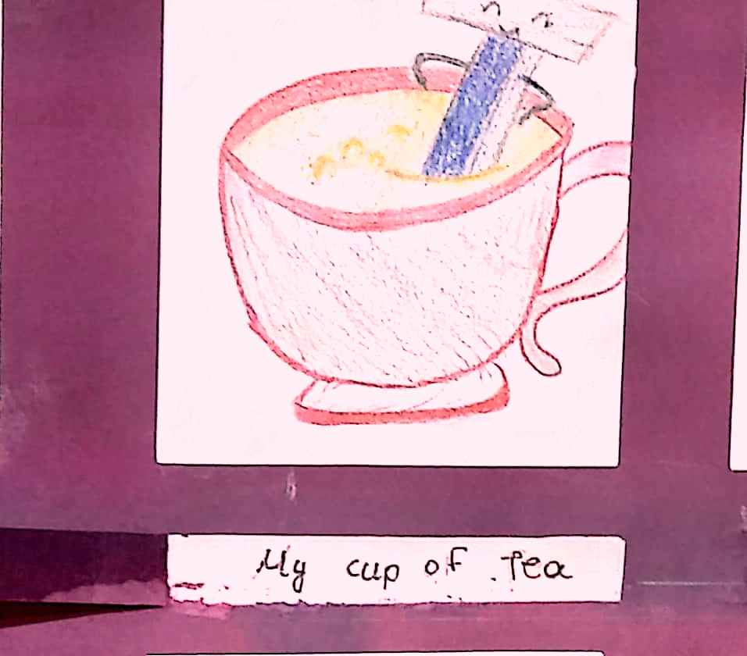

The meaning:
When you have an activity that you repeat again and again, because it suits you, this activity is your cup of tea.

Examples:
• I am very good at swimming. It’s my cup of tea.
• Daytime television isn’t my cup of tea.
• Thanks for your invitation, but I will pass, because basketball isn’t really my cup of tea.
• Shopping is my cup of tea!
• I don’t like spicy food; it’s just not my cup of tea.

BREAD AND BUTTER

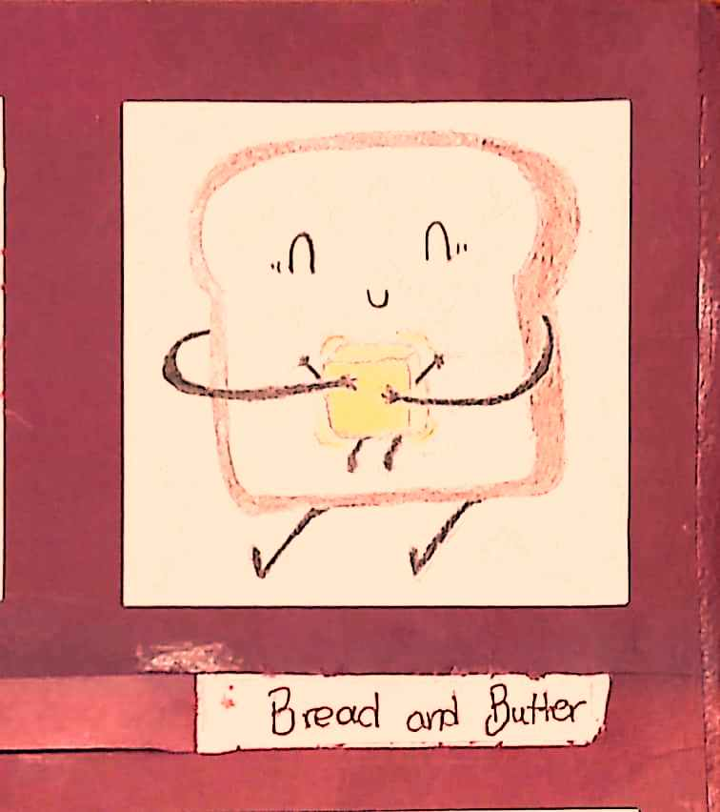
The meaning:
When you have a profession that provides you with the money to earn your life.

Examples:
- I am a lawyer, but these days I work like a delivery guy for my bread and butter.
- I’m an artist at weekends, but being a manager is my bread and butter.
- When I asked my grandpa about his old work, he said that on those days his bread and butter was sailing.

THE APPLE OF SOMEONE’S EYE

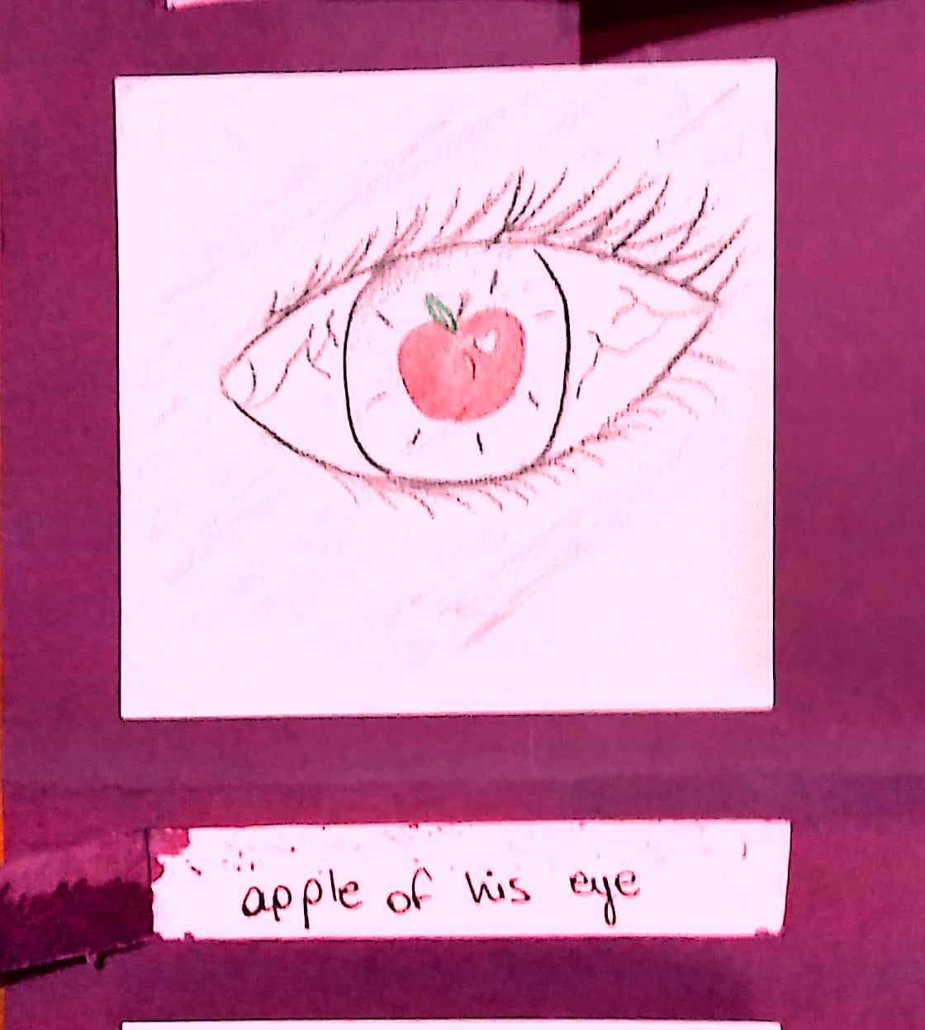
The meaning:
The most precious person in someone's life.

Examples:
• Family, especially my sister, is the apple of my eye.
• He has three children, but his youngest son is the apple of his eye.
• Buying him a new phone to replace his 3-months-old one, showed that his son is the apple of his eye.

HAVE A SWEET TOOTH

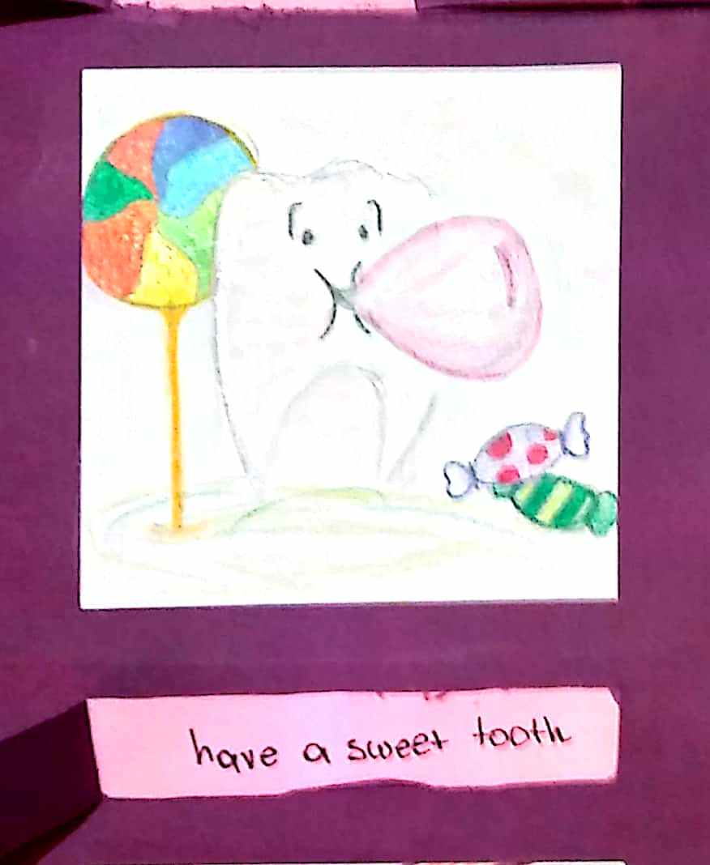

The meaning:
If you have a sweet tooth, you like sweet food very much.

Examples:
• Andrew loves chocolate and cakes; he has a sweet tooth.
• I have a sweet tooth, so it is difficult for me to give up eating chocolates.
• I have a sweet tooth and I will surely get fat!

THE SPICE OF LIFE

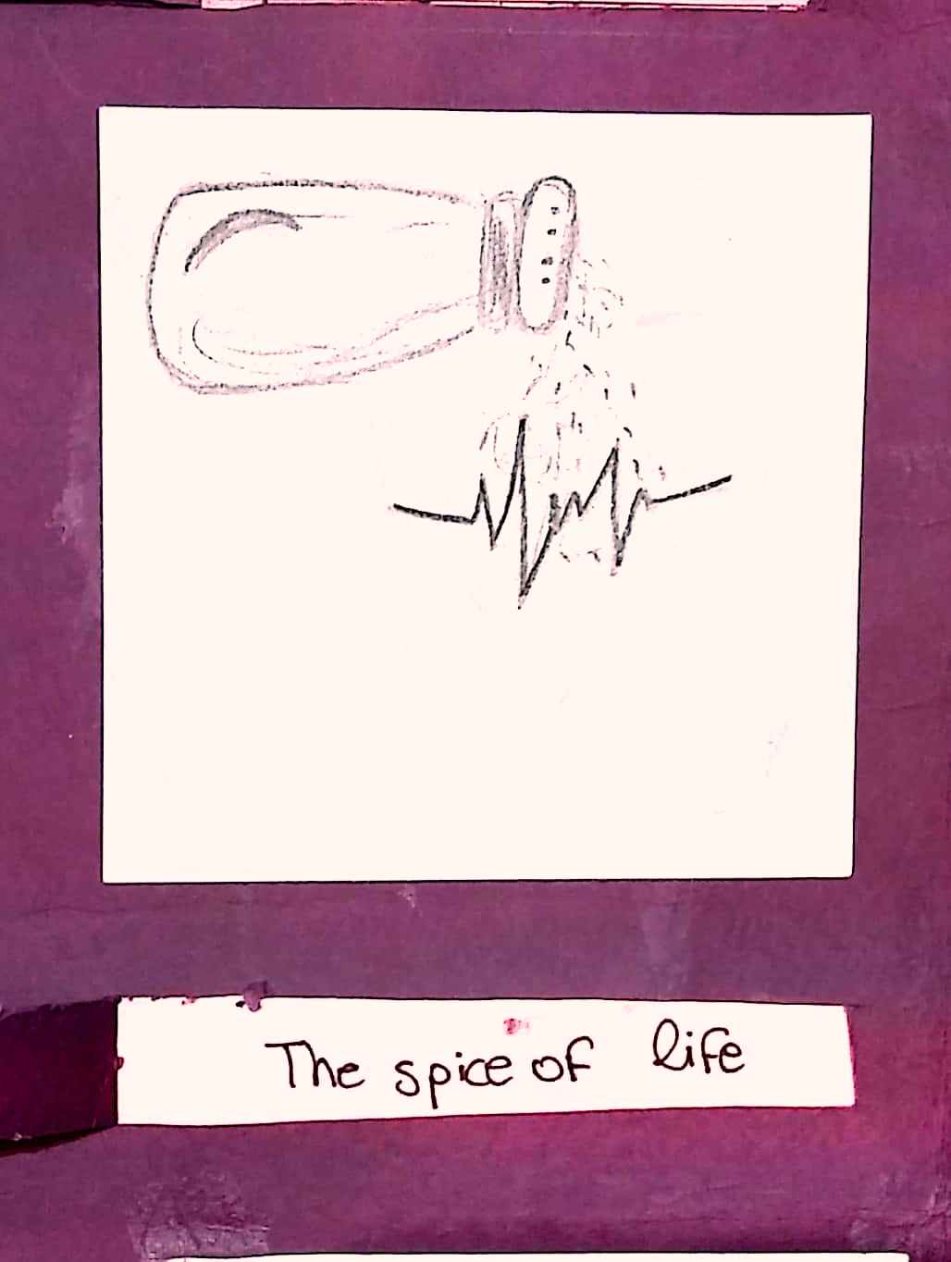

The meaning:
When you enjoy something in your life very much, this is the spice of your life.

Examples:
• For me, tennis is the spice of life.
• Football is the spice of his life. He plays all day with his friends.
• Friendship is the spice of life.
• Having fun, is always making my life more interesting; it’s the spice of my life!

FOOD FOR THOUGHT
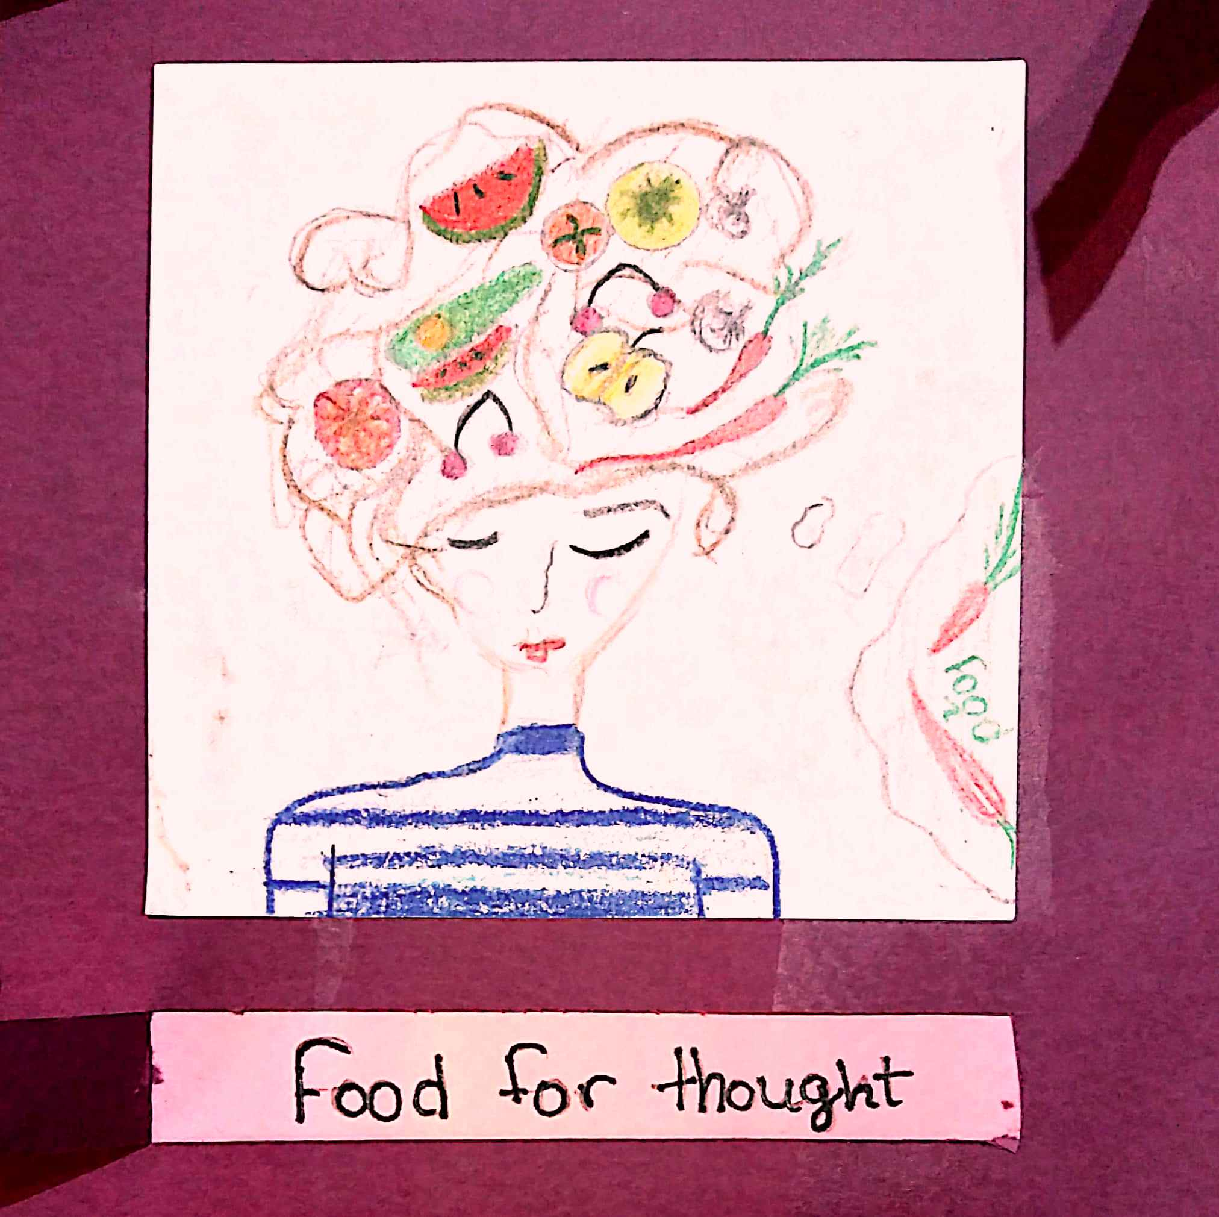

The meaning:
If you give someone food for thought, you make them think carefully about something.

Examples:
• Books are good food for thought.
• To listen to her speak at such conferences, is real food for thought.
• The book about health, gave me food for thought.
• I am sure this report will give food for thought to these member states that have not signed yet.

SPILL THE BEANS

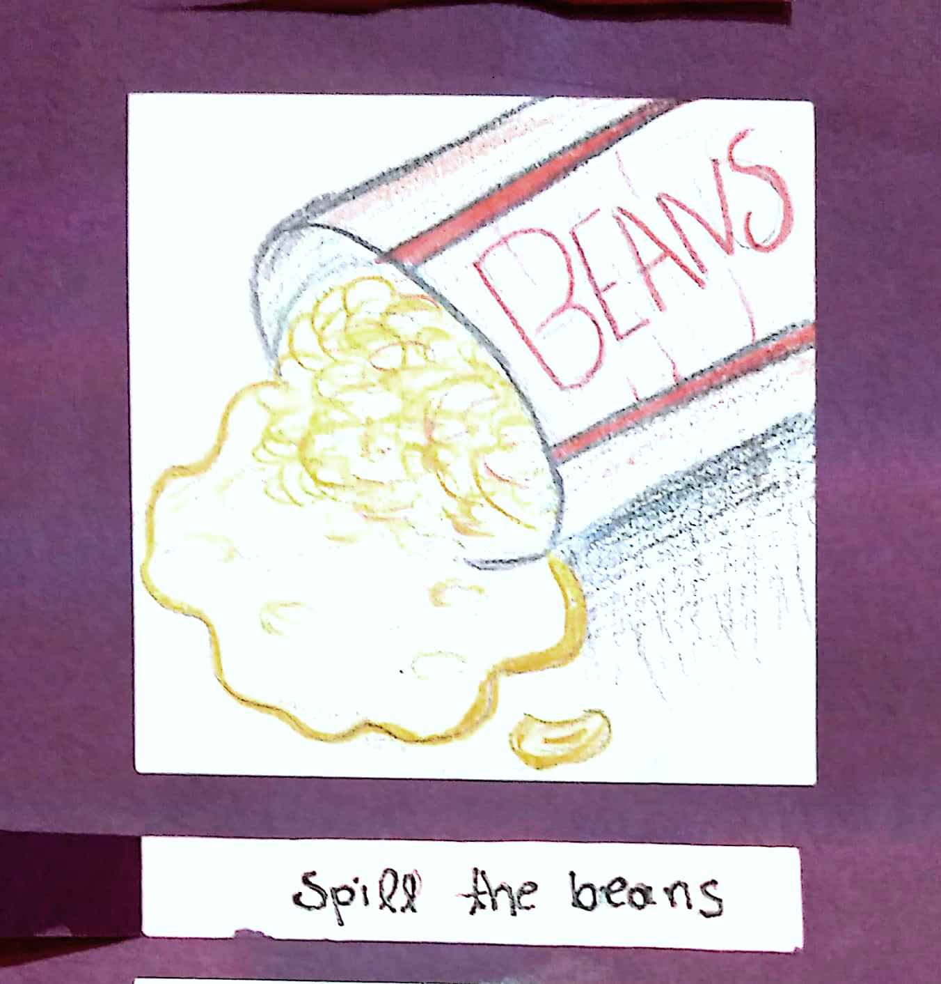

The meaning:
When you reveal a secret and create a lot of turmoil in a group of people.

Examples:
• We’ll all be there at 6 for the surprise party, so please don’t spill the beans and tell her.
• I trusted Kate with my secrets, but she spilled the beans!
• George doesn’t trust Bill anymore, as Bill always spills the beans and tells all George’s secrets to everyone in school.
• I don’t trust him to keep a secret. He will definitely spill the beans and tell everyone!

A COUCH POTATO

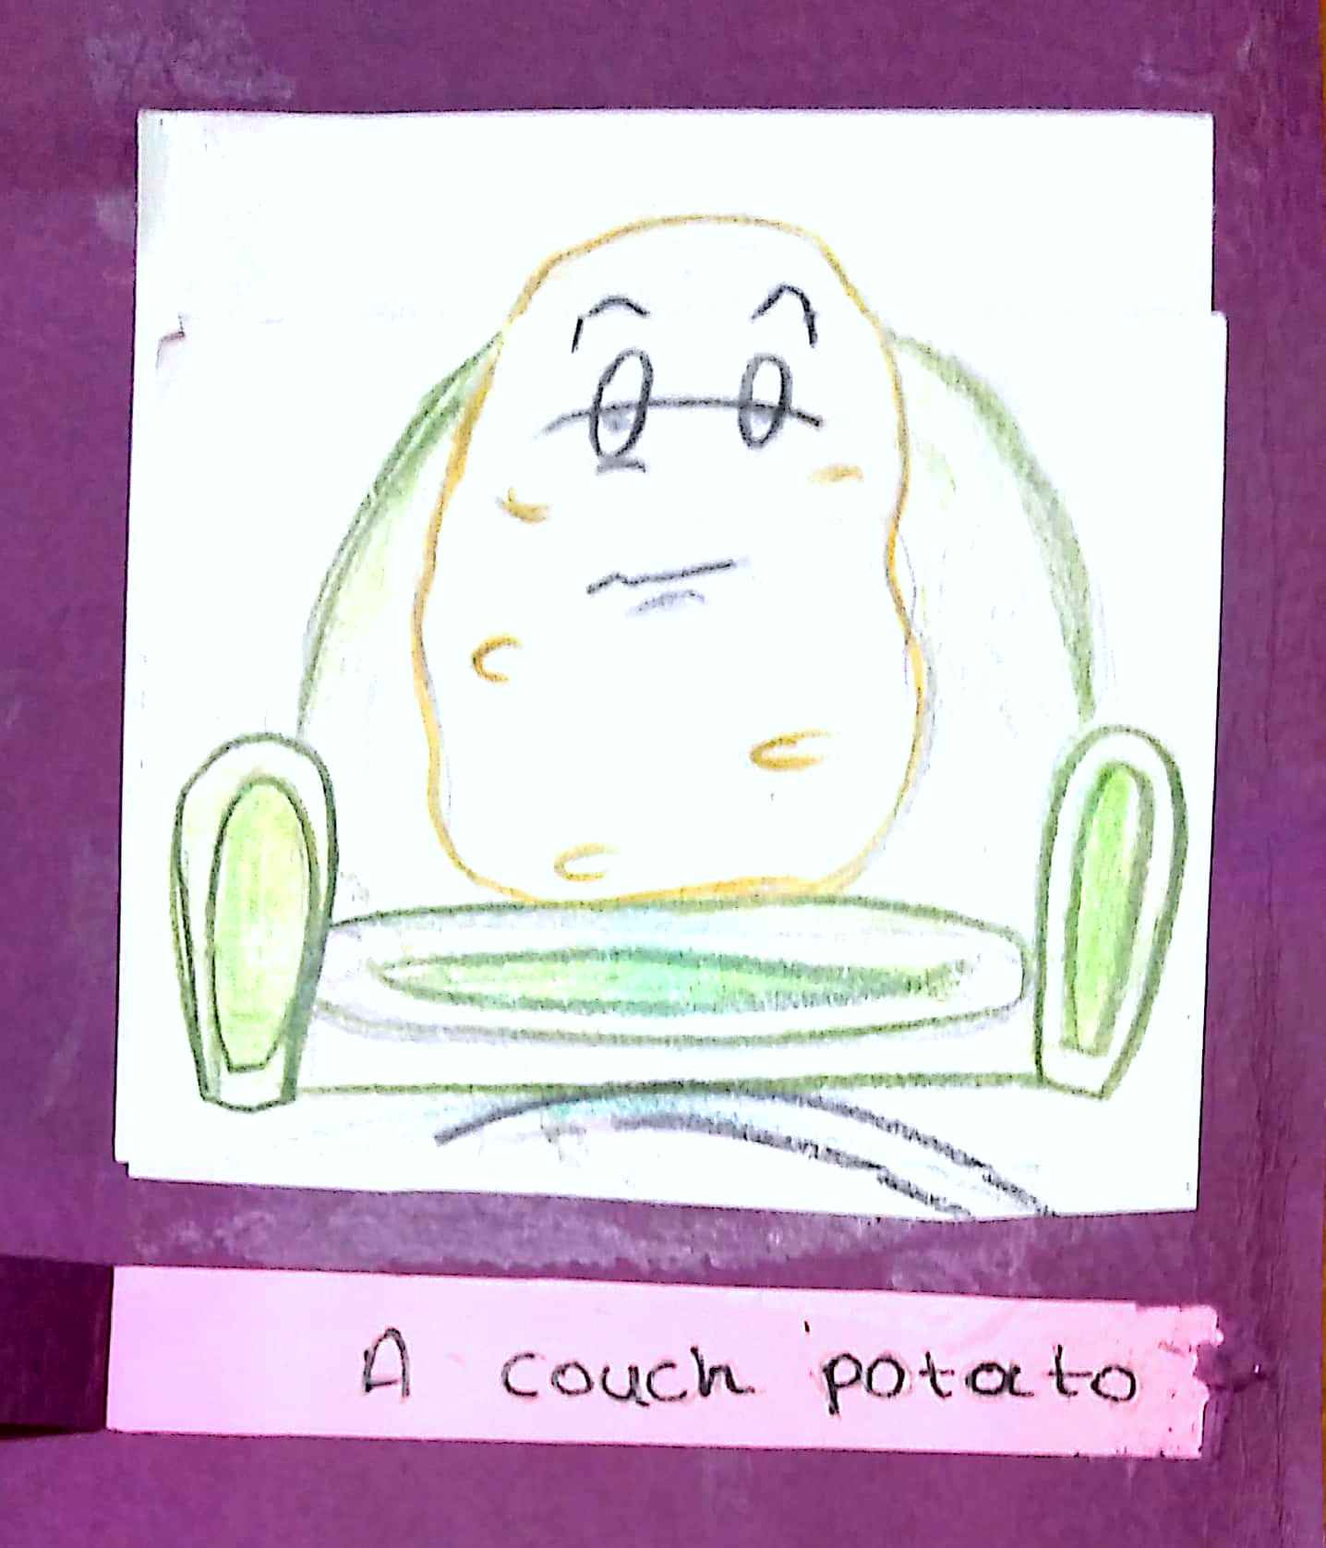

The meaning:
A couch potato is someone who is very lazy and idle.

Examples:
• If you continue sitting and watching a lot of television, you won’t have an active life and you will become a couch potato.
• It would be better for your health to do some exercise than being a couch potato.
• Bill is becoming a couch potato. He is watching TV all day, doing nothing else!

AS COOL AS A CUCUMBER!

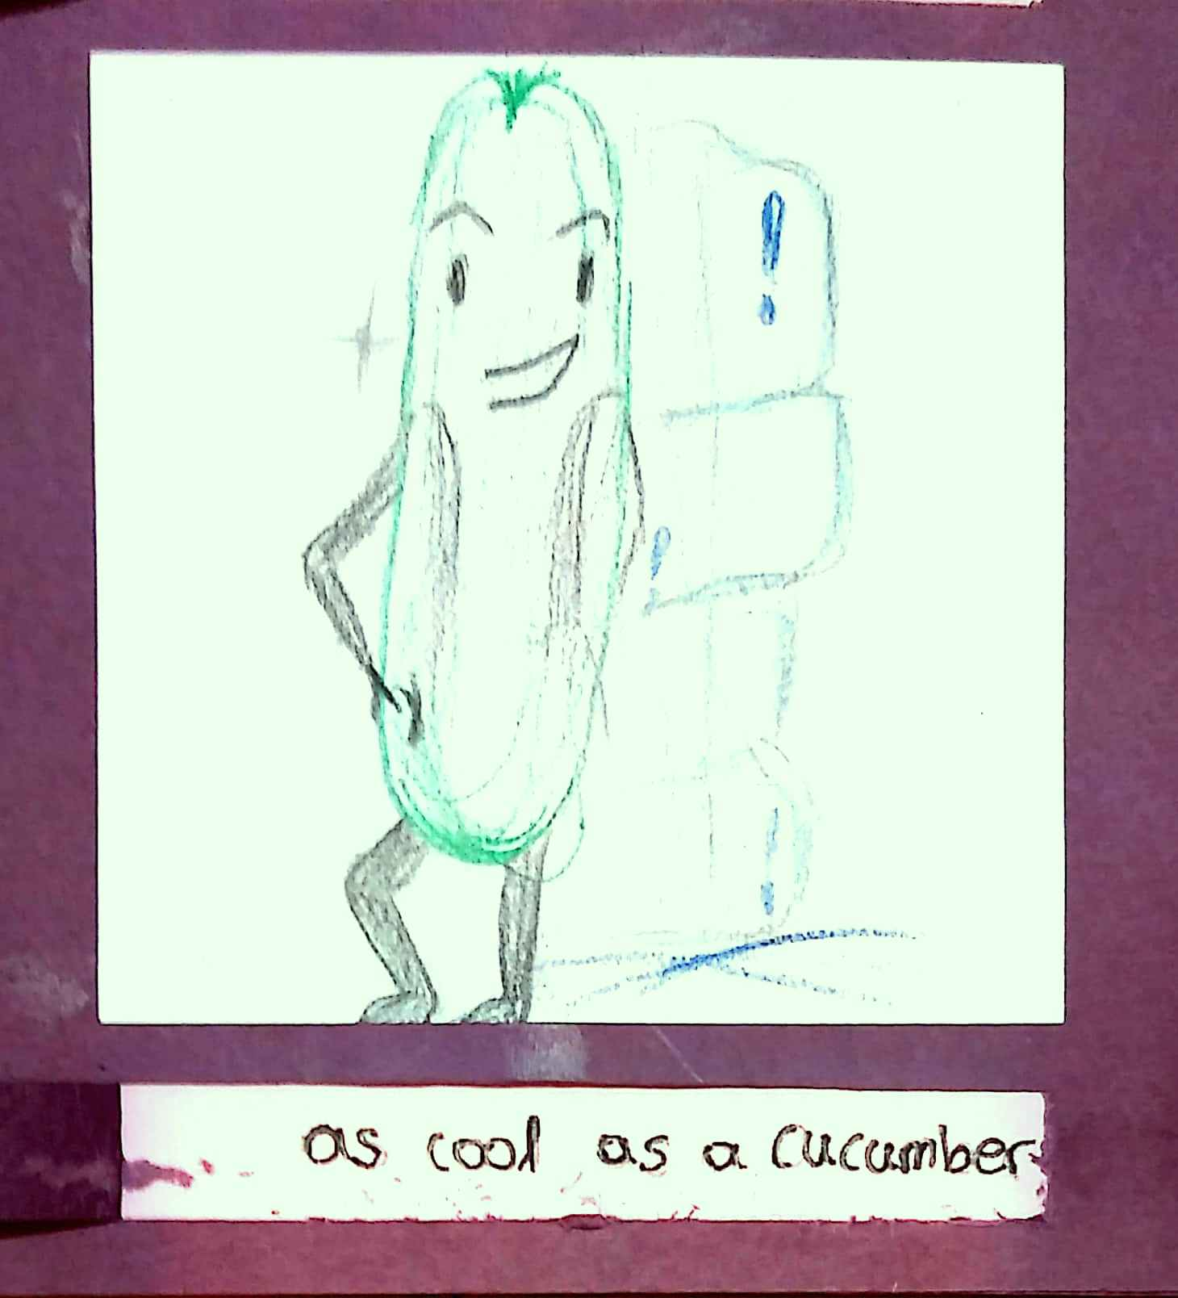

The meaning:
When someone stays calm no matter what happens around him/her.

Examples:
• He was as cool as a cucumber even when he was caught red handed, stealing money from the drawer.
• On the first day of school, all the kids were anxious, but Jim walked in as cool as a cucumber.
• While all the pupils were clapping their hands, my friend Anna was as cool as a cucumber as if nothing had happened.

